CASA0004 — MSc Urban Spatial Science | Yuyue Xia
A Multi-Criteria Approach for Optimising the Spatial Planning of
Electric Vehicle Charging Infrastructures in Greater London

1. Background and Motivation
The decarbonisation of road transport is central to the UK's net-zero commitments. Two policy targets frame this dissertation:
- The Zero Emission Vehicle mandate (HoC Library 2025, R002) requires all new cars and vans to be zero-emission by 2035, with a rising manufacturer sales-share obligation under the ZEV mandate reaching that endpoint.
- TfL/GLA (2025, R005) estimate 43,000–51,000 public chargepoints required in London by 2030, rising to 69,000–79,000 by 2035, against a current stock of approximately 25,500.

The core planning problem is not technical but distributional. Market-driven deployment concentrates investment where EV ownership is already highest (disproportionately affluent areas) creating a self-reinforcing cycle that excludes communities most likely to benefit from clean transport access.

Two findings establish the equity motivation:
- Lopane and Zhong (2025, P008) show via Spatial Autoregressive (SAR) modelling that London's apparent positive correlation between deprivation and chargepoint accessibility disappears once spatial autocorrelation is controlled for. The equity is a statistical artefact of small inner-city LSOA footprints.
- The dissertation's own EDA in Camden produces Pearson r = −0.042 [to be recalculated with income domain score] — a counter-intuitive slightly negative value explained by the same small-area density inflation.

These findings motivate an explicit equity-weighted planning framework: one that integrates heterogeneous demand estimation, income-deprivation weighting, and location-allocation optimisation.

2. Literature Review and Research Gap

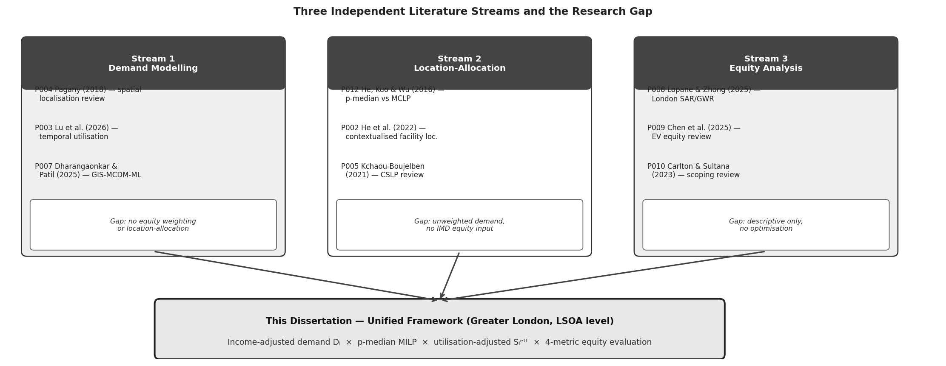
Figure 1: Three independent literature streams and the unified research gap addressed by this dissertation

2.1 Stream 1: Demand Modelling
- Pagany (2018, P004): reviews spatial localisation methods, identifies driving-age population as the dominant empirical demand base for urban EV charging models.
- He et al. (2022, P002): introduces Dᵈ = D × Pd × Ppub , multiplicative demand structure calibrated from Hong Kong survey data (Pd = 0.25, Ppub = 0.50). Direct methodological ancestor of this dissertation's demand formula.
- Lu et al. (2026, P003): demonstrates that temporal dynamics in utilisation matter for capacity planning, motivation for incorporating actual utilisation schedules.

2.2 Stream 2: Location-Allocation Optimisation
- He, Kuo and Wu (2016, P012): comparative experiment among Set Covering, MCLP, and p-median (PMP) in Beijing. Key finding: PMP achieves 35.74% lower demand-weighted distance vs MCLP but covers 20.68% fewer demand nodes. This structural tendency to under-serve low-demand (often deprived) areas directly motivates the IMD equity uplift.
- Kchaou-Boujelben (2021, P005): establishes node-based modelling as appropriate for urban residential slow-charging contexts, documents 800 m walking-distance threshold as the standard service radius.

2.3 Stream 3: Equity Analysis
- Chen et al. (2025, P009): systematic review of 91 EV equity studies, recommends composite deprivation indices as more theoretically grounded equity proxies than raw chargepoint density.
- Carlton and Sultana (2023, P010): identifies the demand priority function concept (Nazari-Heris 2022) (multiplicative uplift in disadvantaged areas) as the nearest precedent for the (1 + α × IMDᵢ) functional form.
- Lopane and Zhong (2025, P008): London SAR/GWR analysis 2021–2024, demonstrates deprivation-accessibility reversal once spatial autocorrelation is controlled. Directly motivates LSOA-level equity weighting.

2.4 Research Gap
No existing study simultaneously:
- estimates heterogeneous income-deprivation-weighted driving-age-population demand at LSOA level,
- selects new on-street chargepoint locations through a p-median location-allocation model using that equity-adjusted demand weight, and
- evaluates outcomes across systematic scenario analysis using both efficiency and equity metrics.

Each component exists independently across the three streams. Their integration in a single planning framework at LSOA resolution in Greater London — with income deprivation as the equity channel and utilisation-adjusted supply as the baseline — constitutes this dissertation's methodological contribution.

3. Research Question and Objectives
Research Question:
How can an income-deprivation-weighted p-median location-allocation framework optimise the spatial planning of new public on-street EV charging infrastructure across Greater London at LSOA level?

Four sequential objectives operationalise the research question:

O1：How can spatially heterogeneous, income-deprivation-adjusted EV charging demand be estimated at LSOA level using Census 2021 TS007, IoD2025 File 7 Income Score (rate), and DfT EV Tracker Year 1 calibrated parameters?

O2：How does the spatial distribution of existing on-street EV charging supply — expressed as utilisation-adjusted effective capacity (Sᵢᵉᶠᶠ) — compare to income-adjusted demand across Greater London LSOAs, and where are supply gaps most concentrated relative to income deprivation?

O3：Which on-street locations should be selected for new chargepoint installation, and how does the optimal set shift as the equity weighting parameter α increases from 0 to 0.5?

O4：How does the income-deprivation-weighted model compare to the unweighted baseline across four efficiency and equity metrics, and at what value of α does equity improvement begin to plateau relative to efficiency cost?

4. Data Sources
Dataset | Source / Coverage | Key Variables | Role
Census 2021 TS007 | ONS / Nomis (2023) LSOA 2021 | Age by single year | Pᵢ = residents aged 17+ (driving-age demand proxy)
IoD2025 File 7 | MHCLG (Oct 2025) 33,755 LSOAs 2021 | Income Score (rate) [0.002–0.998] | IMDᵢ — income deprivation proportion used directly as equity weight
join_august2025.csv | GLA/Zapmap Aug 4–10, 2025 | evse_id, lat/lng, location_c, charing_start, charging_duration, power_band, device_max_power | ur_j & Sᵢᵉᶠᶠ computation; power EDA
OpenStreetEV_GLA | GLA/Zapmap Restricted access | location_id, latitude, longitude,  location_category, location_type, borough | Existing on-street charging location registry. Used to: (1) define 50 m exclusion buffer around all location_category = 'On-Street' records; (2) validate road-segment physical feasibility as a reference. Not a candidate site source.
OSM Highway Network | Geofabrik London (2024) | highway linestrings, parking:lane tags | Candidate site generation (Source 2): roads with confirmed on-street parking
ONS LSOA 2021 Boundaries | ONS Census 2021 | LSOA21CD, geometry | Spatial join backbone; LSOA centroids as demand nodes I
DfT EV Tracker Y1 | Ipsos for DfT (2024) §8.5 travel diary n ≈ 627 BEV | Charging frequency, location type | Ppub = 0.40 calibration (1.8 ÷ 4.4 events); NTS 2024 Table NTS0909 cross-validates
TfL EV Strategy 2025 | TfL / GLA (2025) | Borough chargepoint targets 2030/2035 | Policy validation: compare outputs vs 43–51k target (R005)

5. Methodology
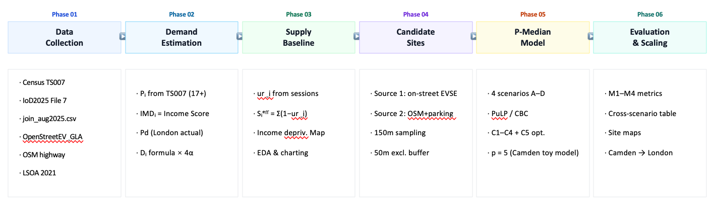
Figure 2: Six-phase analytical pipeline — Camden toy model validates the full pipeline before scaling to Greater London

5.1 Phase 1: Demand Estimation
The equity-adjusted demand weight per LSOA i:
Dᵢ = Pᵢ × Pd × Ppub × (1 + α × IMDᵢ)
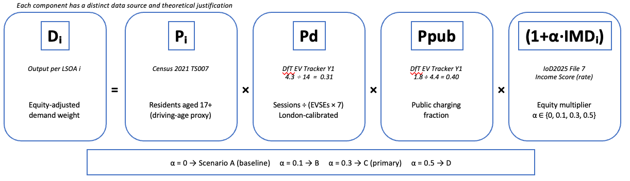
Figure 3: Demand formula components, data sources, and calibration values
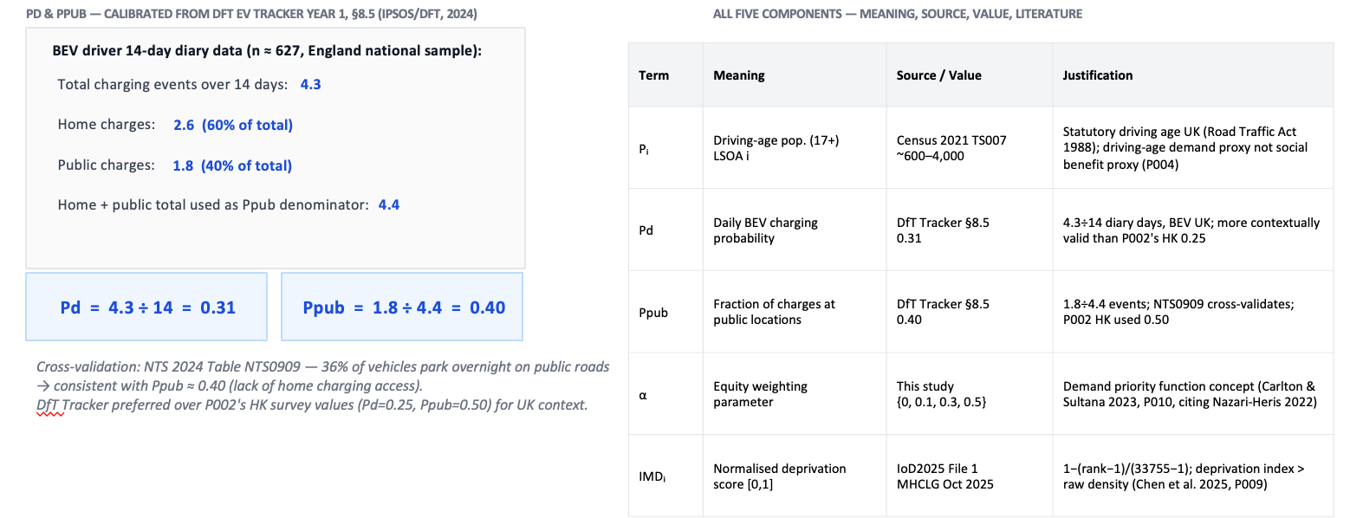

- Pᵢ Driving-age population (17+), Census 2021 TS007. The 17-year threshold reflects UK statutory minimum age for a Category B licence (Road Traffic Act 1988). Pᵢ is a demand proxy, not a social benefit proxy.
- Pd Daily BEV charging probability. DfT national estimate (Pd = 4.3 ÷ 14 = 0.31).
- Ppub Fraction of charges at public locations. DfT EV Tracker Y1 §8.5: 1.8 ÷ 4.4 = 0.40. National Travel Survey 2024 Table NTS0909 (36% of vehicles park overnight on public roads) cross-validates. Ppub is retained as a national value as it reflects a behavioural split less spatially variable than charging frequency.
- IMDᵢ Income deprivation weight. Directly the 'Income Score (rate)' field from IoD2025 File 7. Represents the proportion of LSOA i's population experiencing income deprivation [0.002–0.998]. Higher = more deprived. No normalization required; direction is correct (higher score → more uplift). Income deprivation is the dimension most directly relevant to EV charging access (inability to afford home charging installation, barrier to EV ownership). Note: IMDᵢ in this dissertation denotes specifically the income deprivation domain score from IoD2025 File 7, not the composite Index of Multiple Deprivation rank. The notation is retained for consistency with the demand formula structure.
- α Equity weighting parameter. Tested across {0, 0.1, 0.3, 0.5} in four scenarios. When α = 0, Dᵢ = Pᵢ × Pd × Ppub (pure efficiency baseline).

Why Car Ownership Rate Cᵢ is Excluded: Including Cᵢ would suppress demand in income-deprived LSOAs (where car ownership is constrained) while the IMD multiplier simultaneously attempts to boost it — creating a conceptual contradiction and ambiguous equity direction. Excluding Cᵢ preserves a single, unambiguous equity channel.

5.2 Phase 2: Supply Baseline — Utilisation-Adjusted Effective Capacity
He et al. (2022, P002) identified incorporating "actual charger utilisation schedules" as a key limitation of connector-count-based supply measurement. This dissertation addresses that limitation directly using join_august2025.csv.
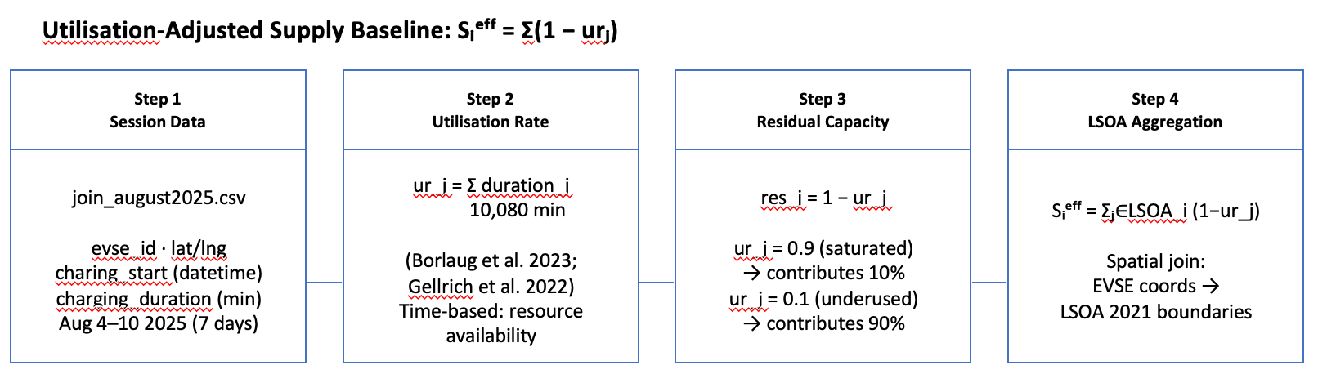
Figure 4: Four-step computation of utilisation-adjusted effective supply Sᵢᵉᶠᶠ

Following the time-based utilisation definition formalised by Borlaug et al. (2023, Transportation Research Part D), who note that time-based utilisation "may be better suited for certain applications (e.g., determining resource availability)":

ur_j = Σ charging_duration_j / (7days × 24h × 60min) = Σ duration_j / 10,080 min

where the denominator is the total observation window (7 days × 1,440 min/day). Equivalent definitions are used by Gellrich et al. (2022, Switzerland nationwide case study) and Hardinghaus et al. (2020). Topal (2025, IJLCT) applies the same socket-level session data structure (start time + duration) to compute capacity utilisation rates.

The residual effective supply per connector (1 − ur_j) is aggregated to LSOA level:

Sᵢᵉᶠᶠ = Σⱼ∈LSOA_i (1 − ur_j)

Interpretation:
- urⱼ = 0.90 (saturated) → contributes 0.10 units of effective supply
- urⱼ = 0.10 (underused) → contributes 0.90 units of effective supply
An EVSE present in OpenStreetEV_GLA but absent from join_august2025.csv is treated as having zero observed sessions during the reference week, and thus contributes 1.00 unit of residual capacity. This is a conservative upper-bound assumption; absence from the session table may reflect genuine zero usage, incomplete CPO data reporting, or a join mismatch — declared as a data completeness limitation.

Two roles of Sᵢᵉᶠᶠ in the dissertation:
- EDA and supply characterisation: spatial distribution, identification of charging deserts (Sᵢᵉᶠᶠ ≈ 0), and correlation with income deprivation decile.
- Post-hoc evaluation: cross-reference with p-median outputs to assess whether selected sites serve previously undersupplied areas.

Why Sᵢᵉᶠᶠ does not enter the objective function: Dᵢ is a population-based demand index (units: weighted persons); Sᵢᵉᶠᶠ is a residual-capacity index (units: effective connectors). Combining them in a single expression without a dimensionally consistent conversion factor would produce a mathematically computable but substantively uninterpretable weight. The decision preserves internal consistency of the mathematical formulation.

5.3 Phase 3: Candidate Site Generation — On-Street Only
New chargepoints in this dissertation are strictly on-street installations: equipment mounted kerbside adjacent to on-street parking bays, or on existing lamp posts, within the public highway reserve. This excludes dedicated surface car parks and private off-street parking areas. Candidate sites are generated from one primary source (OSM highway network), with OpenStreetEV_GLA serving as an exclusion reference rather than a candidate source.
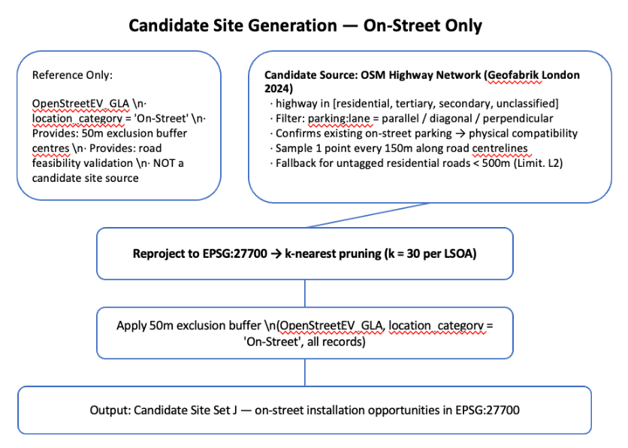
Figure 5: Candidate site generation

Source : OSM Highway Network (Geofabrik London 2024)
- Filter highway types: residential, tertiary, secondary, unclassified.
- Filter: parking:lane:both / left / right = parallel / diagonal / perpendicular. These tags confirm existing on-street parking on that segment — establishing physical compatibility with chargepoint installation.
- Sample candidate points at 150 m intervals along road centrelines using geometry.interpolate(d) in geopandas. The 150 m sampling interval ensures adequate spatial coverage of candidate points without generating an excessively large candidate set that would impede MILP tractability.
- Fallback if parking:lane coverage insufficient: retain residential roads < 500 m length (declared as Limitation L2).

Post-merge step: A 50 m exclusion buffer is applied around all on-street charging locations recorded in OpenStreetEV_GLA (location_category = 'On-Street'), regardless of their activity level during the observation window. Candidate points within this buffer are removed. This prevents selecting locations already in immediate proximity to existing provision. The output is the candidate site set J in EPSG:27700.

Computational Tractability
To ensure computational tractability at Greater London scale (~4,994 LSOAs), a k-nearest-neighbour pruning strategy is applied prior to optimisation. For each LSOA centroid i, only the k = 30 nearest candidate sites are retained as feasible assignment options, yielding a sparse distance matrix of approximately 150,000 binary assignment variables. This pruning is theoretically justified: the p-median optimal assignment never allocates a demand node to a distant facility when a nearer open facility exists (Daskin, 1995). Sensitivity to k is tested at k = 20 and k = 40.

5.4 Phase 4: P-Median Location-Allocation Model
The location-allocation problem is formulated as a p-median Mixed Integer Linear Programme (MILP).

Parameters: p (number of sites to open): set to 5 for the Camden toy model; tested at p ∈ {100, 250, 500} for Greater London, representing low, medium, and high investment scenarios respectively. For context, London's 2030 target requires approximately 17,500–25,500 additional public chargepoints beyond the current stock of 25,500 (TfL/GLA 2025, R005); p = 500 represents a strategic on-street pilot rather than full-gap closure. The dissertation optimises spatial placement rather than final installed connector capacity — one selected candidate point represents one new on-street charging location.

Objective function (minimise total demand-weighted distance):
min Σᵢ∈I Σⱼ∈J Dᵢ · dᵢⱼ · yᵢⱼ

variable definitions:
I = set of all LSOA demand nodes; |I| = 130 (Camden toy model) or ~4,994 (Greater London)
J = set of all candidate on-street sites generated from OSM highway + parking:lane tags, after 50 m exclusion buffer; |J| pruned to k = 30 nearest per LSOA before optimisation
Dᵢ = equity-adjusted demand weight for LSOA i = Pᵢ × Pd × Ppub × (1 + α × IMDᵢ). Because Pd and Ppub are constants identical across all LSOAs, they do not affect which sites are selected — only Pᵢ and (1 + α × IMDᵢ) determine the spatial ranking of demand. Dᵢ is a planning need weight, not a forecast of observed charging sessions.
dᵢⱼ = Euclidean distance in metres between the centroid of LSOA i and candidate site j, computed in EPSG:27700 (British National Grid). Used as a proxy for walking distance. All distances are pre-computed into a sparse |I| × k matrix before the solver is called.
yᵢⱼ ∈ {0, 1} = assignment variable; yᵢⱼ = 1 if LSOA i is assigned to candidate site j in the optimal solution, 0 otherwise. Each LSOA is assigned to exactly one open site (constraint C2).
xⱼ ∈ {0, 1} = site selection variable; xⱼ = 1 if candidate site j is selected (opened), 0 otherwise. Exactly p sites are opened (constraint C3).

The objective minimises the sum of demand-weighted distances across all LSOAs to their assigned sites. Because Dᵢ is higher for income-deprived LSOAs when α > 0, the solver is implicitly penalised more for leaving deprived areas far from selected sites — this is how equity weighting enters the optimisation without requiring a separate objective term.

Constraints:
- C1: yᵢⱼ ≤ xⱼ ∀i, j — demand assigned only to open sites.
- C2: Σⱼ yᵢⱼ = 1 ∀i — each LSOA assigned to exactly one site.
- C3: Σⱼ xⱼ = p — exactly p sites opened.
- C4: xⱼ, yᵢⱼ ∈ {0,1} — binary integrality.
- C5: (optional): yᵢⱼ = 0 if dᵢⱼ > r = 800 m — service radius; tested in Phase 2 of the toy model.

Why p-median (not MCLP): P012 (He, Kuo and Wu 2016) demonstrates that PMP achieves 35.74% lower demand-weighted distance vs MCLP in an EV charging context. The PMP's structural tendency to under-serve low-demand (often deprived) areas is precisely what the IMD equity multiplier counteracts. Solver: PuLP/CBC (open-source MILP).

No capacity constraint in core model: A meaningful capacity constraint requires converting demand weight units (population-based) to service-capacity units (charging events per connector per day). This conversion depends on utilisation data, which is now available via join_august2025.csv — but the conversion introduces a unit-consistency dependency between the supply baseline and the objective function. Capacity constraints are declared as a future extension (Limitation L3).

5.5 Phase 5: Scenario Analysis

Scenario | α | Label | Max Uplift | Primary Purpose
A | 0 | Efficiency Baseline | 0% | Dᵢ = Pᵢ × Pd × Ppub. Demand weight = driving-age population only; Pd and Ppub cancel out in spatial ranking. Replicates unweighted p-median (P012). Benchmark for all metrics.
B | 0.1 | Mild Equity | 10% | Tests lower boundary of equity–efficiency trade-off. Modest shift toward more deprived LSOAs.
C | 0.3 | Moderate Equity (Primary) | 30% | Central methodological contribution. Most income-deprived LSOA receives 30% demand uplift vs least deprived.
D | 0.5 | Strong Equity | 50% | Upper boundary test. Determines whether equity gains continue or plateau beyond α = 0.3.
For Greater London, each of the four α scenarios is run under three values of p (100, 250, 500), yielding 12 model configurations in total. The Camden toy model uses p = 5 across all four α values for pipeline validation.

5.6 Phase 6: Evaluation Framework — Four Metrics
Metric | Definition | Focus | Lit. Basis
M1 Avg Dist. | M1 = ( Σᵢ Pᵢ · dᵢⱼ*(α) ) / ( Σᵢ Pᵢ ) Population-weighted mean distance (m) using fixed Pᵢ weights across all scenarios. | Efficiency | P012, P002
M2 Coverage | Σᵢ Pᵢ·[dᵢⱼ* < 800 m] / Σᵢ Pᵢ Driving-age pop. fraction within 800 m | Reach | P005
M3 IMD Gap | Mean coverage (Decile 10) / Mean coverage (Decile 1) Ratio = 1.0 → equity; > 1.0 → affluent areas better served | Income equity | P008, P009
M4 Gini | Gini coeff. of per-LSOA coverage rates 0 = perfectly equal; 1 = maximum inequality | Distribution | P009

M1 uses fixed driving-age population weights Pᵢ rather than the equity-adjusted Dᵢ, ensuring that efficiency cost is measured on a consistent basis across scenarios with different α values. The model's optimisation objective value (Σᵢ Dᵢ · dᵢⱼ*) is reported separately as a diagnostic indicator but is not used for cross-scenario efficiency comparison, as its weighting structure changes with α.

6. Expected Results

Directional hypotheses derived from model logic and P012 findings — not numerically pre-specified targets:

Hypothesis | Prediction | Basis
H1 Site clustering (Scenario A) | Sites cluster near highest driving-age population, disproportionately non-deprived areas with some existing provision. IMD Decile 1 LSOAs expected to be poorly served. | P012: unweighted p-median concentrates in high-density nodes.
H2 Equity shift (Scenario C) | Scenario C shifts sites toward high-population, income-deprived LSOAs. M3 (IMD gap) narrows; M4 (Gini) falls. This is the primary empirical test of the dissertation's contribution. | Demand priority function (P010); equity weighting direction (P009).
H3 Modest efficiency cost | M1 (avg distance) under Scenario C exceeds Scenario A by a limited margin. Equity redistribution achieved without dramatically increasing average travel burden. | P012 distance performance; London's dense urban network reduces equity–efficiency trade-off.
H4 α saturation (Scenario D) | Incremental equity gains C→D smaller than A→C. Confirms diminishing returns at α = 0.3 as near-optimal for equity–efficiency balance. | Marginal uplift analysis; to be confirmed empirically.

7. Updated EDA Approach

The EDA will be re-run with the following changes from the previous version:
- Switched from composite IMD rank (File 1) to income deprivation score (IoD2025 File 7, column 'Income Score (rate)'). Theoretical motivation: income deprivation is most directly relevant to EV charging access; composite IMD mixes income with crime, health, and education deprivation.
- Re-computed as Pearson r between income deprivation decile and EVSE supply metrics. The previously reported r = −0.042 (composite IMD decile vs EVSE density per km²) will be replaced. The r value is left as [TBC] pending re-execution. When supply is normalised by driving-age population (Sᵢᵉᶠᶠ per 1,000 residents), the correlation with income deprivation is expected to be negative — i.e., more income-deprived LSOAs have lower effective supply per capita — reflecting the theoretical market-driven deployment bias.
- A choropleth map of income deprivation (IMDᵢ) overlaid with Sᵢᵉᶠᶠ across London LSOAs will be produced to show spatial correlation patterns beyond the scalar Pearson r.
- join_august2025.csv will be cleaned and explored: utilisation rate distribution, power tier breakdown, and temporal patterns (hourly/daily).

8. Limitations

# | Limitation | Mitigation / Declaration
L1 | Ppub = 0.40 is a national average applied uniformly across all London LSOAs. Intra-urban variation (e.g. higher public charging dependency in income-deprived areas lacking home charging access) is not captured. | DfT Tracker provides national, not sub-London estimates at LSOA resolution. Pd and Ppub retained as a behavioural-split parameter expected to be less spatially variable than frequency.
L2 | OSM parking:lane tag coverage may be incomplete across London, leaving some eligible road segments without a confirmed parking status tag. Candidate points on untagged residential roads < 500 m are retained as a fallback (declared conservative assumption). OpenStreetEV_GLA on-street locations partially compensate by providing verified road-segment feasibility evidence as an exclusion reference, but do not enter the candidate set directly. | Fallback: untagged residential roads < 500 m retained as conservative candidates. OpenStreetEV_GLA provides physical feasibility reference for exclusion buffer but does not enter candidate set.
L3 | No capacity constraint in the core p-median model. The unit-consistency problem between Dᵢ (population-weighted) and Sᵢᵉᶠᶠ (effective connectors) means a direct constraint would require a dimensionally consistent conversion factor. | Declared as a future extension. Sᵢᵉᶠᶠ is used in evaluation and EDA rather than in the objective function.
L4 | 2021 Census population base used in a market evolving rapidly in 2024–2025. Direction of bias is conservative: 2021 Pᵢ likely underestimates 2025 driving-age demand. | Does not affect relative scenario comparisons, which depend on spatial ordering of Dᵢ rather than absolute demand magnitudes.
L5 | The (1 + α × IMDᵢ) functional form is original to this dissertation. The nearest precedent (Nazari-Heris 2022 via P010) uses a different specific form. Choice of α ∈ {0, 0.1, 0.3, 0.5} is not externally calibrated. | Explicitly framed as a methodological contribution. Sensitivity across four α values constitutes the scenario analysis addressing O4.
L6 | GLA/Zapmap session data covers only 7 days (Aug 4–10, 2025). Seasonal and day-of-week variation in utilisation is not captured. | Reference week declared explicitly. Temporal extension to longer observation windows is a natural direction for future work (Borlaug et al. 2023 cover 2.5 years).
L7 | Grid connection capacity not modelled. UKPN substation proximity and hosting capacity are real deployment barriers. | Power tier EDA (from join_august2025.csv power_band field) provides descriptive context. Full grid constraint modelling deferred to future work.
L8 | k-nearest pruning introduces a spatial constraint: LSOAs can only be assigned to sites within their k = 30 nearest candidates. If the optimal unconstrained assignment would require a farther site (e.g. in areas with very sparse candidate coverage), pruning may marginally affect solution quality. Sensitivity is tested at k = 20 and k = 40. | Sensitivity tested at k = 20 and k = 40. In dense urban London, 30 nearest candidates within typical walking distance provides sufficient local alternatives.

9. Key References

Borlaug, B., Yang, F., Pritchard, E., Wood, E. and Gonder, J. (2023) 'Public electric vehicle charging station utilization in the United States', Transportation Research Part D, 114, 103564. doi: 10.1016/j.trd.2022.103564.
Daskin, M.S. (1995) Network and Discrete Location: Models, Algorithms, and Applications. Wiley-Interscience. [Theoretical justification for k-nearest pruning in p-median models.]
Carlton, E. and Sultana, S. (2023) PRISMA-ScR scoping review of equity in EV charging access [P010].
Chen, X. et al. (2025) Systematic review of EV charging equity, 91 empirical studies [P009].
DfT / Ipsos (2024) EV Tracker Year 1, Section 8.5, n ≈ 627 BEV respondents [R003].
Gellrich, M., Block, A. and Leikert-Böhm, N. (2022) 'Spatial and temporal patterns of electric vehicle charging station utilization: a nationwide case study of Switzerland', Environmental Research: Infrastructure and Sustainability.
Hardinghaus, M., Lochner, M. and Anderson, J. (2020) 'Real-world insights on public charging demand and infrastructure use from electric vehicles', Environmental Research Letters, 15(10), 104030.
He, J. et al. (2022) 'Spatial planning of public EV charging infrastructure in a high-density city using a contextualised location-allocation model', Transportation Research Part A, 152 [P002].
He, S.Y., Kuo, Y.-H. and Wu, D. (2016) 'Incorporating institutional and spatial factors in the selection of optimal locations of public electric vehicle charging facilities', Transportation Research Part C, 67, 131–148 [P012].
House of Commons Library (2025) Zero Emission Vehicle Mandate, CBP-7480 [R002].
Kchaou-Boujelben, M. (2021) 'Charging station location problem', Transportation Research Part C, 132 [P005].
Lopane, F. and Zhong, C. (2025) SAR/GWR analysis of London EV charging equity 2021–2024 [P008].
Lu, X. et al. (2026) Dynamic utilisation modelling for EV charging capacity planning [P003].
MHCLG (October 2025) Index of Deprivation 2025 (IoD2025), File 7: All Ranks, Scores, Deciles and Population Denominators. 33,755 LSOAs (2021 boundaries).
ONS (2021) Census 2021 TS007 Age by Single Year. Nomis. LSOA level.
Pagany, R. (2018) 'Electric vehicle charging infrastructure review', Energies, 11(8) [P004].
TfL / GLA (2025) London Electric Vehicle Infrastructure Strategy [R005].
Topal, O. (2025) 'A comprehensive analysis of capacity utilization rates of fast-charging stations in shopping malls', International Journal of Low-Carbon Technologies, 20, 1646–1660. doi: 10.1093/ijlct/ctaf100.

